**Software Requirements Specifications**

**and**

**Vision and Scope Document**

**For**

**InvestMate**

Prepared by:

David Casente,

Michael O’Brien,

Remy Van Der Ploeg

September 23, 2019

**1. Introduction 1**

1.1 Purpose 1

1.2 Project Scope and Product Features 1

**2. Overall Description 1**

2.1 Product Perspective 1

2.2 User Classes and Characteristics 1

2.3 Operating Environment 2

2.4 Design and Implementation Constraints 2

2.5 User Documentation 2

2.6 Assumptions and Dependencies 2

**3. System Features 2**

3.1 Edit / Onboard Portfolio 2

3.2 Portfolio Assessment 2

3.3 Stock Search Recommender 3

3.4 Individual Stock Assessment 3

3.5 Specific Stock Page 3

3.6 Ask an Analyst 3

**4. External Interface Requirements 3**

4.1 User Interfaces 3

4.2 Hardware Interfaces 3

4.3 Software Interfaces 3

4.4 Communications Interfaces 4

**5. Other Nonfunctional Requirements 4**

5.1 Performance Requirements 4

5.2 Safety Requirements 4

5.3 Security Requirements 4

5.4 Software Quality Attributes 5

**6. Business Requirements 5**

6.1 Background, Customer needs, Business Opportunities 5

6.2 Objectives and Success Criteria 5

6.3 Business Risks 5

**7. Vision of Solution 6**

7.1 Vision Statement 6

7.2 Major Features 6

7.3 Assumptions and Dependencies 6

**8. Scope and Limitations 7**

8.1 Scope of Initial and Subsequent Releases 7

8.2 Limitations and Exclusions 7

**9. Business Context 8**

9.1 Stakeholder Profiles 8

**Appendix A: Application Flowchart 9**

**Revision History**

|  |  |  |  |
| --- | --- | --- | --- |
| **Name** | **Date** | **Reason For Change** | **Version** |
| **Mike, David, and Remy** | **9/19/19** | **Initial draft** | **1.0 draft 1** |
| **Mike, David, and Remy** | **9/23/19** | **Baseline changes after inspection** | **1.1 draft 2** |

**1. Introduction**

1.1 Purpose

This SRS describes the functional and nonfunctional requirements for our InvestMate application. This document is intended to be used by members of the project team and will help verify the correct implementation of the program. Unless stated otherwise, all requirements specifications in this document are high priority and are planned to be in the initial release.

1.2 Project Scope and Product Features

InvestMate will be an investing application with the primary purpose of improving the investment portfolio of the user. InvestMate will allow users to input their current portfolio and the amount of money they are willing to put into the market and will give the user suggestions on stocks to buy, sell and/or hold. InvestMate will also include an individual stock assessment tool and a stock search recommender with similarities to an education tool.

**2. Overall Description**

2.1 Product Perspective

The purpose of InvestMate is to give people who have little to no prior investment knowledge the ability to use good investment strategies. It is more convenient and reliable than searching the web for “good stocks to invest in” and will use trustworthy strategies to give the best recommendation at that current time.

2.2 User Classes and Characteristics

**Prospective Investor**: A prospective Investor is someone who wishes to gain information about relevant stocks without having any of the prior knowledge needed. They are expected to use our application twice per week to stay updated on their portfolio performance.

**Analyst**: An Analyst is someone who answers questions from the prospective investor referencing more qualitative information that InvestMate can’t analyze. They are expected to check daily for questions through InvestMate.

2.3 Operating Environment

OE-1: InvestMate will be a Java application and will leverage the Quotes Yahoo Finance API for Java to retrieve and digest stock information on demand.

2.4 Design and Implementation Constraints

CO-1: All code shall be written in Java

CO-2: All code will require Java Doc compliant commenting and notation

CO-3: Code will conform to the Google Java Style Guide

2.5 User Documentation

UD-1: The system will include tooltips as well as a help page in order to assist users.

UD-2: There will also be guidance included to help users make effective investing decisions

2.6 Assumptions and Dependencies

OE-1: InvestMate is dependent on stock data, and will not be able to operate effectively without the ability to digest stock information through the API.

**3. System Features**

3.1 Edit / Onboard portfolio

The user inputs their stock portfolio and buying power (how much money they are willing to invest) into the program which saves it and can be accessed anytime after when the application is running.

3.2 Portfolio Assessment

We plan on displaying each of the stocks with some simple metrics such as gain/loss since purchase or p/e ratio into one combined portfolio. Also, at the bottom we plan on having an aggregate total of how much your portfolio is worth, plus how much you have gained/lost since using InvestMate.

3.3 Stock Search Recommender

In the Stock Recommender page, the assistant will take in criteria from the user such as what sector they are interested in, how long they plan on holding the stock, and whether they want dividends. Based on the information given, it will return with stock(s) the program thinks will be successful or will not recommend a stock if there are no promising ones.

3.4 Individual Stock Assessment

The Individual Stock Assessment feature will analyze one stock at a time. This feature will primarily teach the user how to analyze the numbers a stock and then be able to project how the stock will perform in the near future.

3.5 Specific Stock Page

The specific stock page will look at an individual stock and give all the relevant data about the stock. It will also give a graph of how it has performed in the past. Lastly, it will provide links to articles relevant to qualitative information about the businesses performance in the news.

3.6 Ask an Analyst

This feature will include a question page where the user can input a question relevant to an individual stock and an analyst will answer the question and how it will affect the stock.

**4. External Interface Requirements**

4.1 User Interfaces

UI-1: All User interfaces will comply with WCAG 2.0 accessibility guidelines

4.2 Hardware Interfaces

No hardware interfaces are required.

4.3 Software Interfaces

SI-1: Main page

SI-1-1: The main page will provide a start point for users to interact with stock searching, individual stock assessment, portfolio assessment, portfolio editing, and portfolio onboarding.

SI-2: Stock search recommender:

SI-2-1: The stock search recommender will allow users to find information about stocks and overview said stock’s projected profitability.

4.4 Communications Interfaces

There are no communication interfaces required.

**5. Other Nonfunctional Requirements**

5.1 Performance Requirements

PE-1: Most traffic on the InvestMate application will take place during active stock market times, 9:30 a.m. to 4:00 p.m. ET. The application will be able to accommodate one users per computer with an internet connection.

PE-2: All pages within the InvestMate application will load in at most in 8 seconds over a 1 MBps modem connection.

PE-3: Responses to queries within the application will take at most 8 seconds to display after user submission.

PE-4: All confirmation messages will be displayed by the system at most 5 seconds after a submission of information by the user.

5.2 Safety Requirements

SR-1: The Application will confirm that a user is at least 18 years old as that is the legal age to begin investing. If the user is not 18, then the user will not have access to creating a portfolio or portfolio assessment, but will have access to all other functions for research and learning purposes.

5.3 Security Requirements

SE-1: All sensitive user information such as the amount of money invested in a stock will be encrypted.

SE-2: Users will be able to sign into their account only on the computer they set up their account on.

5.4 Software Quality Requirements

Availability- The InvestMate application will be available to users with an internet connection 24 hours a day, 7 days a week.

Reliability- An “Ask an Analyst” submission will have a response in at most a week

**6. Business Requirements**

6.1 Background, Business Opportunity, and Customer Needs

The majority of people today do not prioritize saving money, especially young people. It is extremely advantageous and fiscally responsible for young adults to begin saving at an early age and one way to accomplish this is to invest savings in the stock and bond market. However, due to lack of beginner investing tools, people find it difficult to start investing. The purpose of this application is to fill the need for a beginner investing tool, which will provide necessary metrics and information to teach new investors how to manage their savings well and avoid costly mistakes.

6.2 Business Objectives and Success Criteria

BO-1: Have a user base of over ten thousand within three months of launch.

BO-2: Increase average amount invested in each account by 2% a month

SC-1: Have 67% of users “Ask an Analyst” at least once a week

SC-2: Have 75% of users log on at least twice a week

6.3 Business Risks

RI-1: Prospective investors might not believe in the application’s investment strategy (short term outlook) and wouldn’t use the application. (Probability = 0.3; Impact = 7)

RI-2: Prospective investors do not agree with the application’s stock picking strategy and do not use the tool. (Probability = 0.4; Impact = 5)

RI-3: Our algorithm for recommending stocks is flawed and gives users poor advice, which leads to losing prospective investors. (Probability 0.2; Impact = 9)

**7. Vision of the Solution**

7.1 Vision Statement

For beginner investors, the Investor Assistant Application would function as an aid and teacher, which would update the investor on the performance of their purchased stocks, recommend potential new stock investments and give the investor guidance on how to allocate the money in their portfolio. The application would focus on short term investing with a month-long outlook for stock turnover.

7.2 Major Features

FE-1: Edit Portfolio

FE-2: Portfolio Assessment

FE-3: Stock Search Recommender

FE-4: Individual Stock Assessment

FE-5: Specific Stock Page

FE-6: Ask an Analyst

7.3 Assumptions and Dependencies

AS-1: The user of the application is a beginning investor and is connected to the internet.

AS-2: The analysts are able to reasonably answer investing questions given to them from prospective investors

DE-1: The application must be able to communicate with Yahoo Finance API to receive necessary stock information

**8. Scope and Limitations**

8.1 Scope of Initial and Subsequent Releases

|  |  |  |  |
| --- | --- | --- | --- |
| **Feature** | **Demo 1** | **Demo 2** | **Release** |
| FE-1 | Fully Implemented |  |  |
| FE-2 | Not Implemented | Have graphics of page implemented, but not specific advice | Fully Implemented |
| FE-3 | Have graphics and search filters displayed, but not the search algorithm | Fully Implemented |  |
| FE-4 | Not Implemented | Implement first half of stock analysis without projection | Fully Implemented |
| FE-5 | Fully Implemented |  |  |
| FE-6 | Not implemented | Have the user form completed, but not the analyst response | Fully Implemented |

8.2 Limitations and Exclusions

LH-1: The stock picker is not omniscient and cannot not predict what stock prices will increase

LH-2: The Individual Stock Assessment tool uses beginner analysis techniques to make projections and should not be considered to be an accurate projector.

**9. Business Context**

9.1 Stakeholder Profiles

|  |  |  |  |  |
| --- | --- | --- | --- | --- |
| **Stakeholder** | Major Value | Attitudes | Major Interests | its |
| Corporate Management | Potential revenue from application | Support throughout the development process based on promising demos | Teaching users how to invest and potentially making ad revenue from the application | None identified |
| Beginner Investors | Learning how to invest | Eager to learn, but could be reluctant to spend money on stocks | Appreciation of investments | Analysis, metrics and projections are based on beginner investing techniques |
| Analyst | Salary | Excited to help users. However, it could be difficult to explain certain investing concepts to users | Teaching users how to invest and picking potential new investments | Might not have the bandwidth to get to all user “Ask an Analyst” request |

**Appendix A: Application Flowchart**

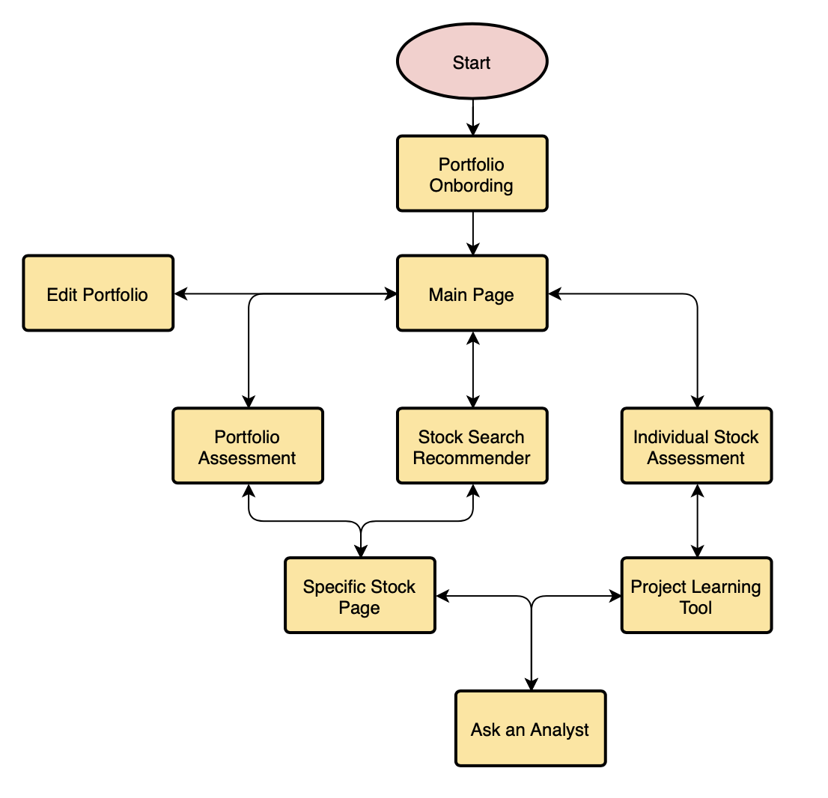

Figure 1

Application architecture flow model 1.0 of the InvestMate program.